S.No | Title | Block Diagram(s) | Gap
1 | An IoT-Based Smart Helmet for Riding Security and Emergency Notification | 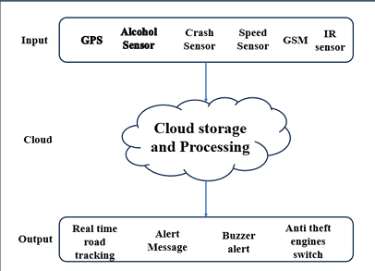  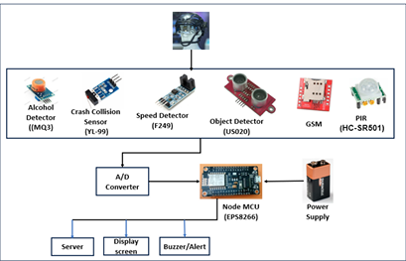 | Relies on GSM and cloud for alert system which might fail in low signal areas.  No helmet presence detection.
2 | IoT based Smart Helmet for Bike Rider Safety | 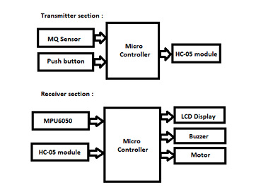 | Cannot differentiate helmet fall from accident, causing false positive detection.
3 | Internet of Things (IoT) based Digital Helmet Design and Deployment | 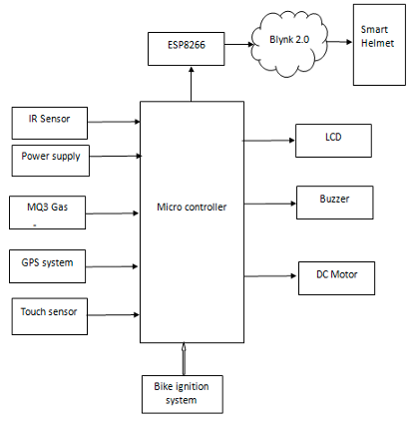 | Relies on internet and cloud for alert system which might fail in low signal areas.  Uses simple touch sensor for helmet presence Ignition system which is easier to bypass.
4 | A Real-Time Development of an Internet of Things (IoT) based Smart Helmet to Identify Road Accidents using Smart Sensors Association | 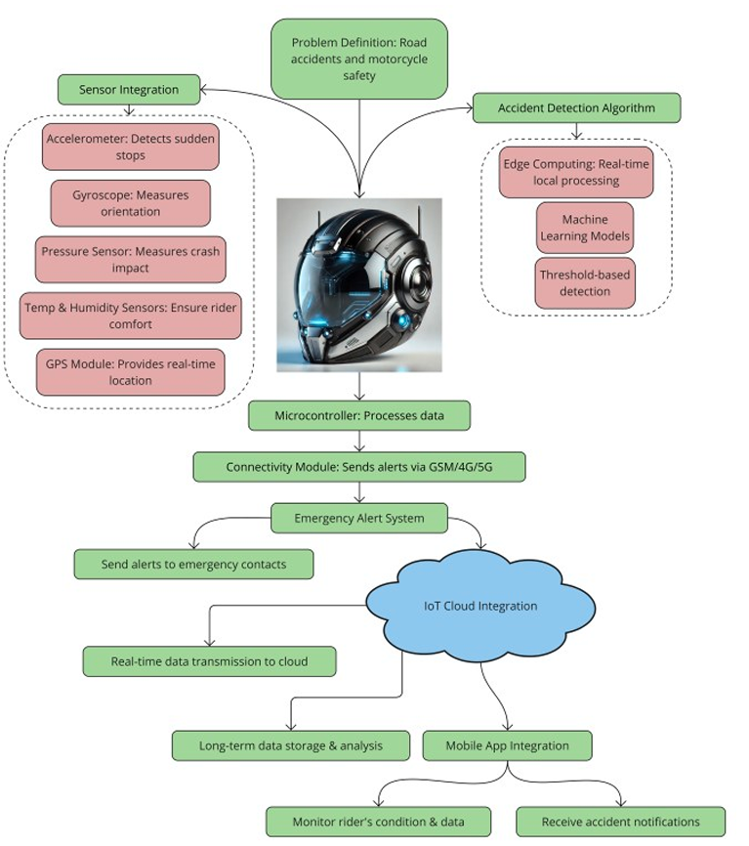 | Only has helmet side detection but no bike side detection and no sound based crash detection.
5 | AI-IoT based smart helmet with Frequency based vehicle control | 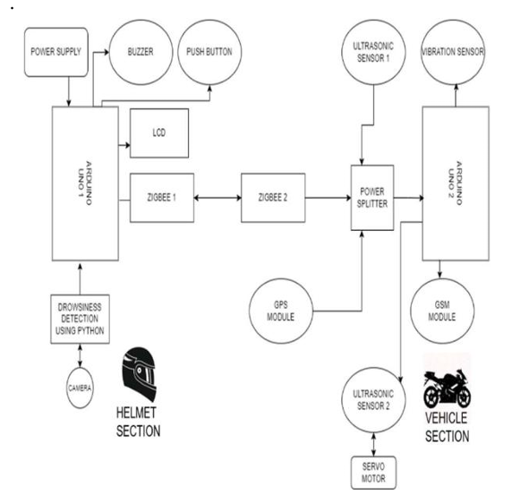
6 | A Crash Response System using LoRa-based V2X Communications | 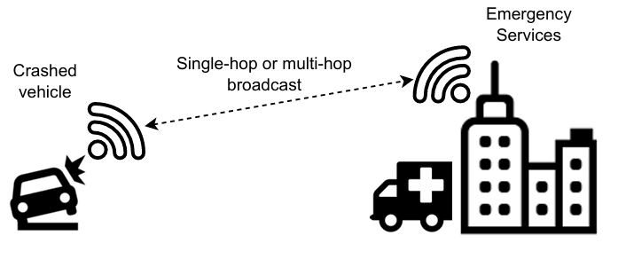
7 | R-AODV: Reverse Ad-Hoc On-Demand Distance Vector Routing Algorithm With LoRa Mesh Based for Emergency Alert System | 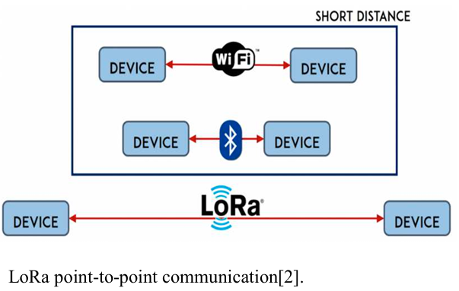  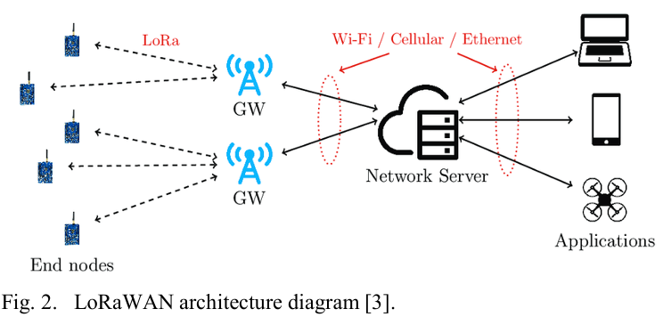
8 | A LoRa based Emergency Communication Device for Disaster Response | 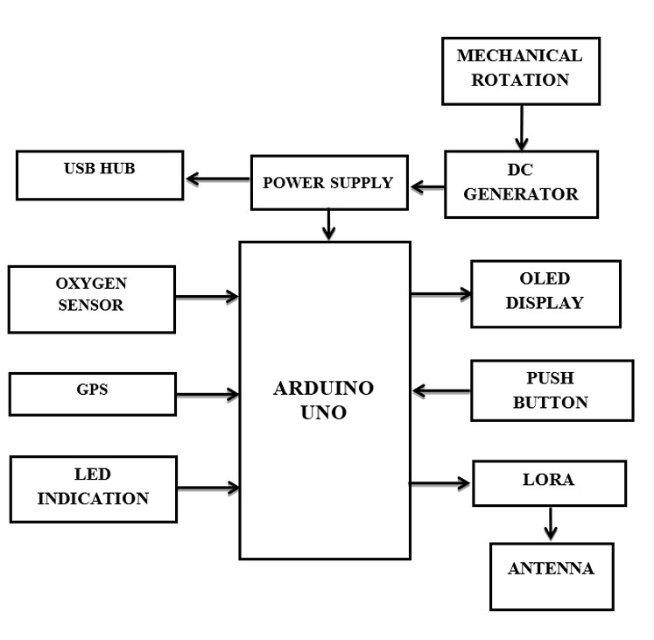
9 | Humanity Lifeline: A Resilient Communication and Sensor Network Framework for Disaster Response | 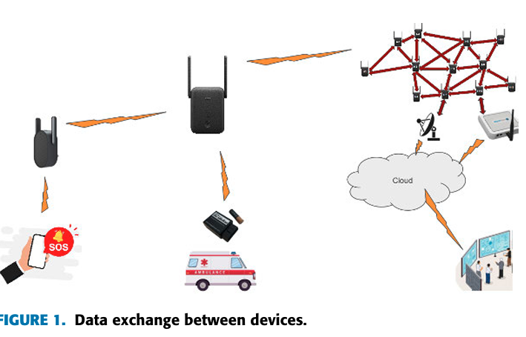
10 | Building Management System with Hybrid edge-cloud processing | 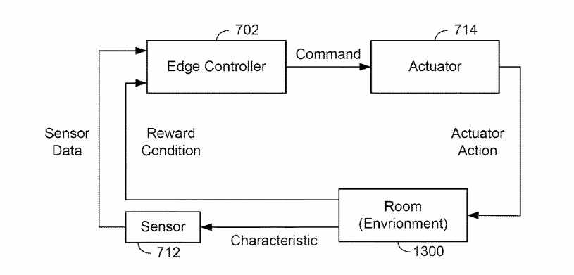  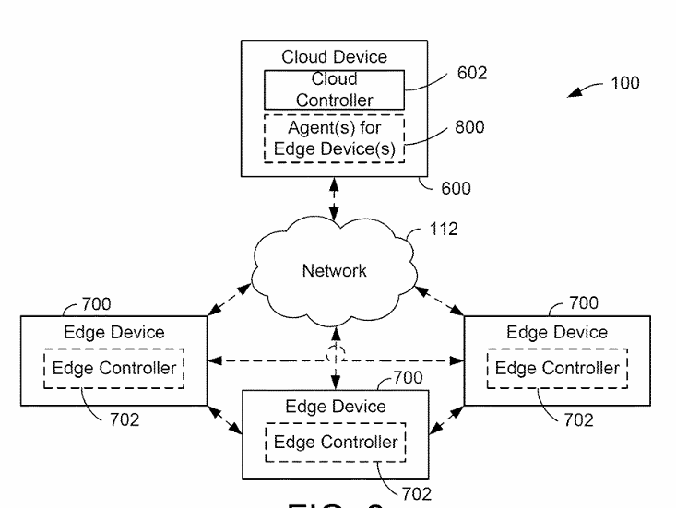
11 | Microservices in Edge and Cloud Computing for Safety in Intelligent Transportation Systems | 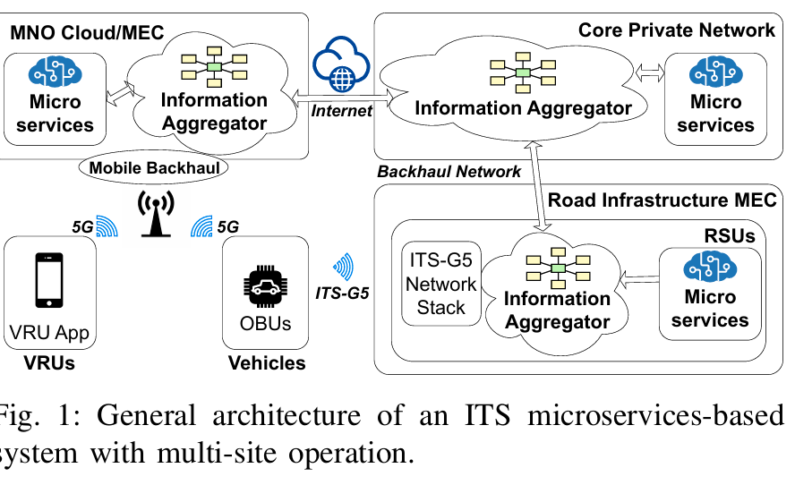
12 | On Edge Coordination in Highly Dynamic Cyber-Physical Systems for Emergency Response | 